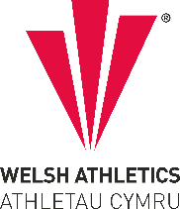

West Wales Regional Athletics Council

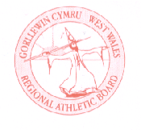
Minutes – West Wales Regional Athletics Council
Friday 6th October 2023
The Old Inn, Penllergaer & Microsoft Teams Meeting

Present: Rob Campion Chairman
Nathan Jones Secretary
Andrew Jenkins Afan Nedd Tawe Schools Athletic Association
Lisa Campion Llanelli AAC
Steve Hames Welfare Officer
Mary Anthony TROTS
Jennifer Boyce Pembrokeshire Harriers

Apologies: Les Cuthbert, Owain Schiavone, Kevin Tobin, Aled Jones-Davies, Neil Thomas, Dic Evans
- Actions from Previous Meeting

- None

- Discussion
- West Wales Cross Country Championships & Welsh Inter Regional Championships
To be held at Pembrey Country Park on Saturday 14th October at the Gwent League 1. Selection race for the Welsh Inter Regional Championships at Newtown on Saturday 18th November. Agreed that top 13 would be selected plus another 2 in each age group.

- Welsh Junior League – West Wales Review
Successful West Wales division over the summer with fixtures held at Neath, Carmarthen and Swansea with full timetable within six hours. Welsh Athletics plan to meet the clubs to discuss the league moving forward, nothing organised as yet.

Each host club will receive ¼ of the profits with ¼ also going to the West Wales region to help support the regions finances.

AGREED: no changes to be made to the current format (7 x clubs making up the West Wales division with opportunity for athletes to take part in all disciplines, will reconsider if cup/plate fixtures are organised as part of the season to decide how clubs qualify. Bring the first fixture to earlier on in the season – April to avoid congestion during June-July.

- Welsh Inter-Regional Championships – Track Meeting 1 Feedback
There was a meeting set up in September to discuss the future and format of the Welsh Inter Regional Track & Field Championships, which RB, SH & NJ attended. Handbook was created back in 2020 which has been followed up until now. A suggestion was brought forward by another region to host a two-day championship or midweek event specific but it was agreed that it wouldn’t be possible to hold a full event programme at this event. The date needs to be carefully planned that it doesn’t clash if it is to attract athletes.

Despite the West region proposing the re-introduction of under 13’s instead of seniors, the other three regions were in favour of retaining U20 and seniors. 3-year rotation of events is the proposal made. Next meeting at the end of the month.

Proposed timetable and rotation of events created by Joyce has been circulated with the minutes. The timetable will need to be reduced when entry number is known as the proposed timetable is currently over 6 hours with no break, combining some disciplines such as 400m Hurdles, relays and u20/senior events.

- West Wales Indoor Championships – January 2024
Dates confirmed around the West Glamorgan Cross Country League and Cardiff Met Non Thomas New Year Open.
Day 1 – 60m, 60m Hurdles, Shot – Saturday 13th January
Day 2 – Long Jump, Triple Jump, High Jump, Pole Vault – Saturday 20th January
Entries agreed as £5 per event, this year’s dates does not clash with other fixtures, 2022 fell during February half term.

200m, 300m, 400m, 800m, 1500m championships for U13 – U17: to be incorporated into the Welsh Athletics Junior Indoor Open Meetings at NIAC, Cardiff on 3rd December and 7th January as in previous years.

- West Wales Merchandise Shop update
Ideas of kit circulated. Ongoing.

- Gerry Batty Award
Nominations to open for the Gerry Batty Memorial Award – U17/U20 Junior Athlete of the Year. Closing date for nominations on 1st December.

- Information - Reports
- General Council
No update to report.

- Track and Field Committee
No update to report. Next meeting on Wednesday 11th October. Agenda looked at ahead of the meeting.

- Officials Secretary
No update to report.

- Road Running/Cross Country Committee
No update to report.

- FMR Committee
Last meeting held on Thursday 5th October. OS & DE attended, main points were:

Review of races. Whilst discussing recent internationals, the committee gave honourable mentions to Iwan Thomas (Carmarthen) and Ollie George (Sarn Helen) on impressive performances in Welsh vests.

British Hill & Fell Championships 2024. Short Race – 27th July 2024 Blisco Dash, Great Langdale, Cumbria. (8km/650m) Long Race – 21st September 2024 Pedol Peris, Llanberis. (28km/2600m) *Decision has been made to change from 10 year age groups (Masters 40+) to 5 year age groups and it's been suggested that Welsh Athletics should follow suit.

European Off Road Championships. Annecy (France) - 31 May - 1 June. Trials for selection will be at the Inter Counties in Sedbergh on 21 April (Seniors and Juniors)

Trail de Guerledan (Brittany) - 18/19 May. 26km - up to 4 men and 4 women. Selection race @ Red Kite Challenge

Welsh Trail Championships. Short Course and Long Course Champs. Short - Red Kite Challenge will be the short course this time (it seems ½ Marathon is short for most European Champs). Long - Trail Marathon Wales @ Coed y Brenin (nr. Dolgellau) was suggested. Juniors - Welsh Champs @ Red Kite Challenge

WMRA International U18 Mountain Running Cup. 20-23 June @ Aguilar de Campoo and Baruello de Santullan (Spain). Red Kite Challenge to be Selection Race (4 junior men / 4 junior women)

- Welfare Officer
No update to report.

- Financial Report
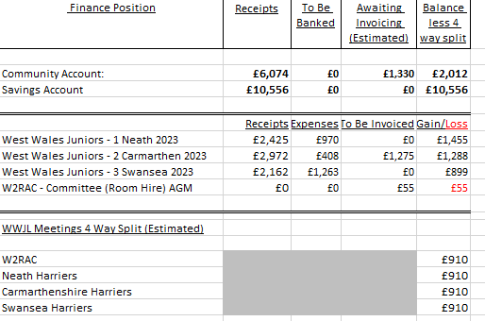
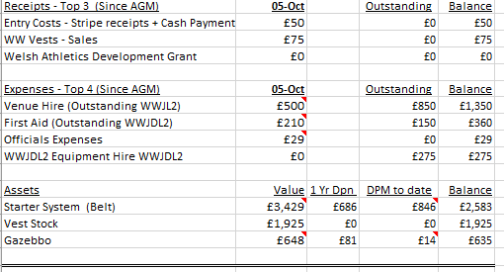
Update;
- Awaiting the Invoices from the West Wales Junior League 2 meeting held at Carmarthen on 17th June 2023. Invoices requested from Carmarthen Harriers are those for Venue Hire, First Aid provision and Equipment hire (including Operator bounty). On settlement of these invoices, payment to the three Junior league host clubs regarding the 4-way split will be made.
- Apart from the above there is only one outstanding invoice (Committee room hire at AGM) still to be received and paid.
- No receipts have been paid into W2RAC bank account since the AGM.

Discussion/Agreement from LC:
- Are West Wales Technical Officials receiving any expenses from the combined JC Gwent League/ West Wales Inter-Region XC Championships being held at Pembrey CP on the 14th October 2023. No
- Are there any upcoming meetings before the end of this calendar year being hosted by West Wales. No
- Are there any non-West Wales hosted meetings before the end of the calendar year where the region will be paying expenses or invoices. No
- I would help me if I could have a list of future meetings likely to accrue expenditure for the Region. That way I could lay down a budget. West Wales Indoor Athletics Championships – January 2024 is next regional event followed by WJDL and West Wales Outdoor Athletics Championships (next summer).

- AOB

- Date of Next Meeting Thursday 7th December at 7:00pm (In person & virtually online)

